# NXT-Gen Scholars Application Form

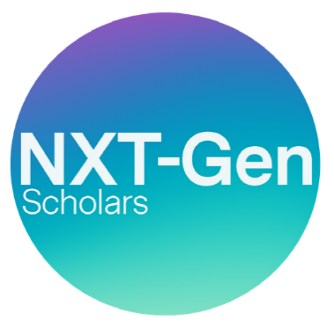

# 2025

Please note we will accept applications in any format (written statement, recording or presentation). Please send all completed application forms to MPA Head of DEI and Programme Leader: [**Helen.choudhury@mpagroup.com**](mailto:Helen.choudhury@mpagroup.com)

## NXT-Gen Scholar

**You …**

1. Have 0 to 3 years’ experience in the Music Publishing or the Music Sector.
2. Proactive and driven to make a change or impact in the music industry.
3. Interested in or already engaged in the music publishing arena.
4. Belonging to 1 or more of the 9 Protected Characteristics.
5. Have the time to commit to the one-year scholarship and act as an ambassador for NXT-Gen.

## NXT-Gen Scholar Benefits: As part of the NXT-Gen scholarship, each scholar will receive the following:

1. Full NXT-Gen membership for a year. NXT-Gen is an MPA membership tier dedicated to nurturing the next generation of music publishers offering unparalleled access to publishing communities, networking events and career-building resources.
2. Access to NXT-Gen network and Futures Group Facebook page for networking and sharing opportunities.
3. A one-on-one mentoring video or phone call with an experienced industry professional to discuss the industry and an opportunity to ask any career-related questions.
4. Employability Skills Workshops.
5. Specialist and Technical Workshops – Guest speakers from the industry.

**First Name:**

**Last Name:**

**E-mail:**

**Date of birth: DD MM YY**

**Address: Occupation/ job title: Industry sector: Company:**

**Years at company:**

**Place of study:**

Page 1 of 4

# NXT-Gen Scholars Application Form



**Written Questions**

**Q1)** In no more than 300 words explain why you would like to become a NXT-Gen Scholar, what would the scholarship mean to you? Please note we will accept this in any format, it can be a written statement, recording or presentation. (Max. 300 words)

Page 2 of 4

# NXT-Gen Scholars Application Form



**Written Questions**

**Q2)** What difference would becoming a NXT-Gen Scholar make to your career?

Please note we will accept this in any format, it can be a written statement, recording or presentation. (Max. 200 words)

Page 3 of 4

# NXT-Gen Scholars Application Form

**Written Questions**

**Q3)** Thinking about your own career or your impact on the music industry, what are your aspirations for the future? Please note we will accept this in any format, it can be a written statement, recording or presentation. (Max. 300 words)

We accept submissions in other formats, such as audio clips or video.

These should be a maximum of 2 minutes long and answer the same questions as the application form. If you need any additional support or need the application form in another format, please email

[**helen.choudhury@mpagroup.com**](mailto:helen.choudhury@mpagroup.com)



Page 4 of 4